Bayno, Jeck Janever M. BSIT502A

DATSYS October 3, 2023

ATTENDANCE ACTIVITY - SQL FUNCTIONS

CODE 1

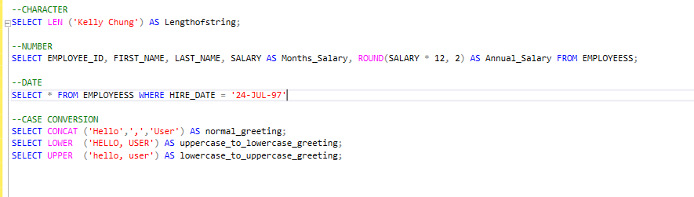

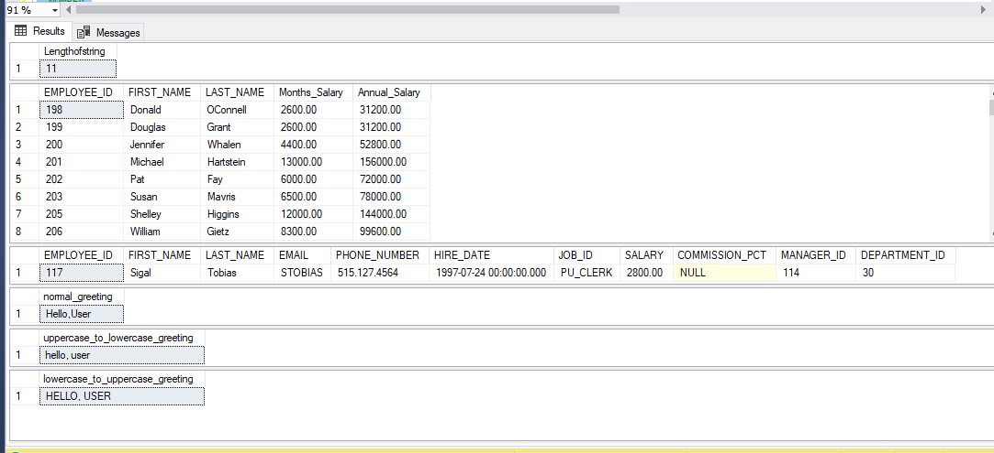

CODE2

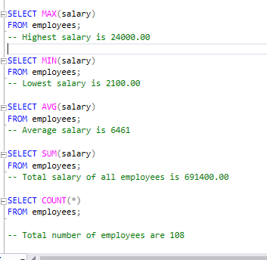

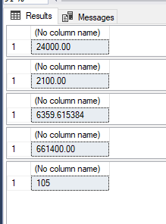

CODE3

